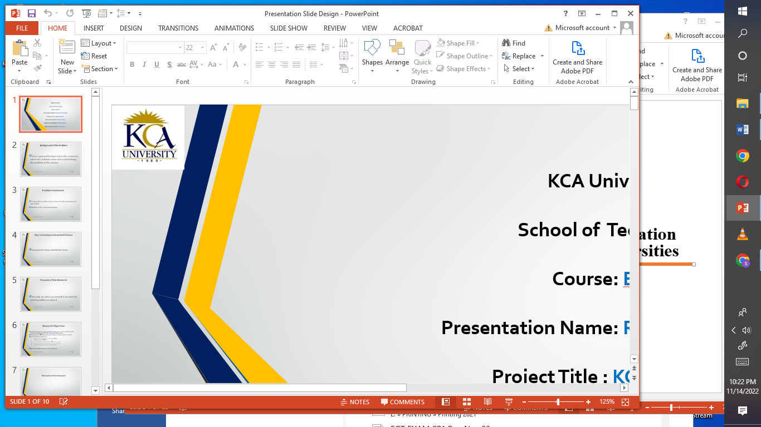**BAC CSN1101: Web Technologies and Internet Applications**

Explore more information on the knowledge processed in the previous learning sessions and undertake the Tasks.

**Required:**

1. **Illustrate** the **Structure** and **Components** of a JavaScript object and Array (use reliable internet information and provide sample values for your variables)
2. **Implement** Any JavaScript Structure to retrieve the content of an Array (use Visual Studio and paste a snapshot of the solution in the PPT document)
3. **Relate** and **Illustrate** the following technologies with regard to information storage and retrieval
4. Web Server
5. Domain Name Server
6. Internet
7. WWW

NB/ Compile a PPT document and include APA Reference